LPW School
Princess Street
Bedminster
Bristol
BS3 4AG

24th September 2021

Dear Parent/Carer

This autumn, all young people aged 12 – 15 are being offered a first dose of the Covid-19 vaccine at the same time as the annual flu vaccine.

Children who are 12 years old and over on the day the School Age Immunisation Service (SAIS) team visits, will be offered a vaccination as part of the in-school vaccination programme. Our local provider, Sirona Care & Health, is legally responsible for the delivery of the Covid-19 vaccine and flu vaccine and will be visiting in LPW School on Thursday 30th September to administer these.

The relevant consent forms for both the flu and Covid-19 vaccines are attached to this letter and should be returned to the school by your child. Parents/carers can provide consent for both the flu and the Covid-19 vaccine, for one or other of the vaccines or neither.

All eligible students will be asked to attend the clinic, where their consent data will be checked by Sirona Care & Health staff. Students without the appropriate consents will not be vaccinated.

For further information about the Covid-19 vaccination programme in schools, please refer to the attached letters or links:
COVID-19 vaccination – A guide for children and young people (publishing.service.gov.uk)

COVID-19 vaccination programme for young people: guidance for parents (www.gov.uk)
COVID-19 vaccination: a guide for eligible children and young people aged 12 to 17

For further information about Sirona Care & Health and the vaccination clinics, please visit: http://www.sirona-cic.org.uk/contact-sirona/ . If you do have any questions or concerns, we are always here to support. Please contact the school on 0117 907 4500.

Yours faithfully,

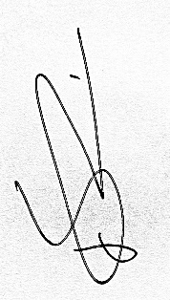

Dan Carter
Head Teacher

